Apply filters to SQL queries

Project description

Database Security & Analysis: Investigating Security Issues with SQL
Role: Security Analyst (Simulated Environment)
Scenario: Investigated potential security issues related to login attempts and employee machines within a large organizational database.
Key Responsibilities:
- Analyzed employees and log_in_attempts tables to identify suspicious activities and potential security breaches.
- Applied advanced SQL filtering techniques, such as AND, OR, and NOT operators, to retrieve relevant records and isolate irregular login behavior.
- Cross-referenced datasets to detect compromised accounts and unauthorized access attempts.
- Ensured secure and accurate data organization to maintain database integrity.
Outcome:
- Produced actionable insights to mitigate risks and enhance overall security posture.
- Demonstrated proficiency in database security analysis and the practical application of SQL in addressing real-world cybersecurity challenges.

Retrieve after hours failed login attempts
To investigate potential security incidents that occurred after business hours, I queried the log_in_attempts table to identify failed login attempts occurring after 18:00.
Task: Examine login activity to identify patterns or suspicious behavior in failed login attempts outside normal operating hours.
Query Details:
- login_time > '18:00': Filtered for login attempts made after 6:00 PM.
- success = 0: Isolated failed login attempts, where the success column indicated failure (value of 0).
The SQL query utilized the WHERE clause with the AND operator to combine these conditions effectively. This resulted in a detailed list of event IDs, usernames, login dates, times, countries, and IP addresses linked to failed login attempts during non-business hours.
The insights gained from this analysis were crucial in identifying unusual patterns, such as repeated IP addresses or login attempts from unexpected locations, facilitating a focused and data-driven response to potential security threats.

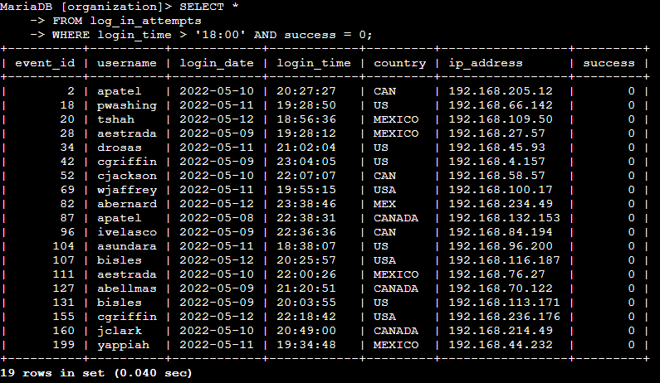

Retrieve login attempts on specific dates
Task: Investigate a suspicious event that occurred on 2022-05-09 by analyzing login activity from the day of the event and the day before (2022-05-08).
To accomplish this, I queried the log_in_attempts table using the following logic:
- login_date = '2022-05-09' OR login_date = '2022-05-08': The OR operator was used to filter and retrieve login attempts that occurred on either of the two specified dates.
This query returned 75 login attempts, enabling a thorough analysis of login patterns during the critical timeframe. By reviewing this data, I identified anomalies or trends relevant to the security investigation, contributing to the overall threat assessment and response process.

Retrieve login attempts outside of Mexico
To investigate suspicious login activity that did not originate from Mexico, I queried the log_in_attempts table to exclude entries where the country column contained values associated with Mexico.
Task: Analyze login attempts by filtering out all records originating from Mexico, where the country column includes both "MEX" and "MEXICO."
Query Details:
- country NOT LIKE 'MEX%': The NOT operator, combined with the LIKE keyword and the pattern MEX%, ensured that all entries with "MEX" or "MEXICO" in the country column were excluded from the results.
This query provided a dataset of 144 unique login attempts originating from countries outside of Mexico. The results included detailed information such as event IDs, usernames, login dates, times, IP addresses, and countries. These insights were critical in narrowing the scope of the investigation and focusing on login activity from non-Mexican origins, enabling more efficient identification of suspicious or unauthorized access patterns.


Retrieve employees in Marketing
Task:
To assist with security updates on employee machines, I needed to retrieve information about all employees in the Marketing department located in any office within the East building.
Query Details:
- department = 'Marketing': This filter ensured that only employees from the Marketing department were included in the results.
- office LIKE 'East%': Using the LIKE keyword with the pattern East%, the query filtered records to include only employees located in offices in the East building (e.g., East-170, East-320).
- AND Operator: Combined both filters to ensure only employees meeting both criteria were selected.
Outcome:
The query returned detailed records, including employee IDs, device IDs, usernames, and their respective office locations. This dataset enabled the team to focus on Marketing department employees in the East building for targeted machine security updates, ensuring an efficient and accurate response to the task requirements.
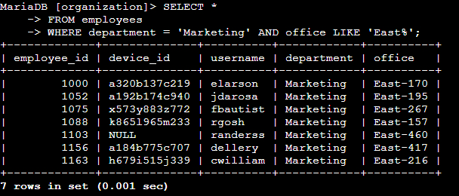

Retrieve employees in Finance or Sales
Task:
To support security updates for employee machines, I needed to retrieve records for all employees working in either the Finance or Sales departments.
Query Details:
- department = 'Finance' OR department = 'Sales': This condition ensured the query selected records where the department column matched either 'Finance' or 'Sales'.
- OR Operator: The OR operator allowed the query to include employees from both departments.
Outcome:
The query successfully returned detailed information about employees in both the Finance and Sales departments, including all relevant columns such as employee ID, device ID, usernames, and more. This allowed the team to focus their security updates on the correct group of employees, ensuring precise targeting for the task at hand.
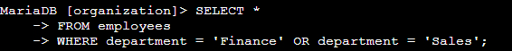

Retrieve all employees not in IT
Task:
To perform a final update for employee machines, I needed to retrieve records for all employees who are not part of the Information Technology (IT) department. This ensured that updates were applied only to those employees who had not already received them.
Query Details:
- WHERE NOT department = 'Information Technology': This filter excluded all employees whose department column was set to 'Information Technology'.
- NOT Operator: The NOT operator was used to invert the filter condition, ensuring the query returned only employees outside the IT department.
Outcome:
The query successfully retrieved records for 161 employees across all departments except IT. These records included essential details such as employee IDs, device IDs, and usernames, which the team could use to target the updates accurately. This approach ensured no unnecessary redundancy in the update process.
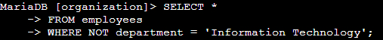

Summary
In this project, I utilized SQL queries to retrieve specific employee and login attempt records based on various conditions. Tasks included investigating suspicious login attempts, filtering data by department and location, and isolating employees requiring updates to their machines. By applying filters with operators like AND, OR, and NOT, I was able to pinpoint relevant data, such as failed logins outside Mexico or employees in the Marketing, Sales, and Finance departments. These queries supported the team’s efforts to address security updates and analyze activity, ensuring the organization’s systems remained secure and up-to-date.
Joel Massicot
ISC2 CC (Certified in Cybersecurity)
joel.massicot@zohomail.eu | 857-788-3808


